Dated :

13.05.2024

25-05-2024

**Simple Notifciation service ( SNS )**

Notification Mechanism

1. Notification from AWS Native services to your email >>>> SNS

2. Notification from AWS Native services to your SMS >>>> SNS

3. Notification from AWS Native service when there is any action >>> SNS

4. Notification from one AWS service to another AWS service >>> SNS

SNS with S3

https://docs.aws.amazon.com/AmazonS3/latest/userguide/ways-to-add-notification-config-to-bucket.html#step1-create-sns-topic-for-notification

**SNS ( N Verginia Region )**

Create a Topic >>>

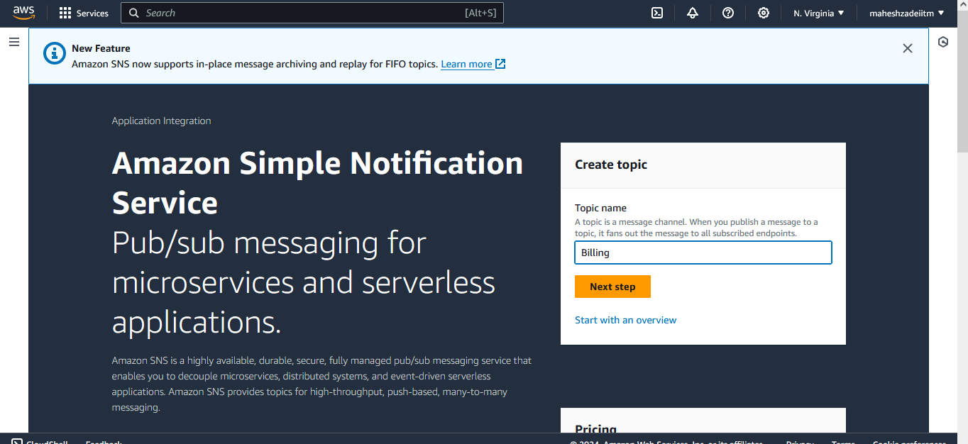

Type >>> Standard

Give Name >>>> billing

Leave all the options

Create a Topic

Open the Topic

Click Create subscription.

Topic ARN >>> Choose your ARN from the bottom.

Protocol >>> Email

Endpoint >>> your email

Create subscription

You should receive your email and that has to be confirmed

After confirmation your status will be showing as "Confirmed"

Just for testing >>>

Click on PUblish a Message at the SNS

Subject - optional >>>> Test by Mahesh

Leave all the options

Click on Publish messages

Now go to your email inbox and check the email

Now SNS Service in activated Successfully in N verginia Region

Pls check and confirm

Thanks